ENGAGE
Faculty of Engineering, Built Environment and Information Technology
Semester Test 2
Module: JPO 152 Additional physics
9 May 2013
UNIVERSITEIT VAN PRETORIA
UNIVERSITY OF PRETORIA
YUNIBESITHI YA PRETORIA

Test information:
Marks | 75 | Total
Duration of paper: | 120 minutes | Lecturer | K Oerder
This test consists of 11 pages including this cover sheet
IMPORTANT
- The examination regulations of the university of Pretoria apply
- All questions are to be answered on this question paper.
- Please show all your working
- Formulas and Useful Constants are given on the last page

Surname: _____________________________________ Student No: _________________
Registered Degree/Field of study: ________________________________
Group: ___________________________________
Total | Q1 | Q2 | Q3 | Q4 | Q5 | Q6 | Q7
/75 | /12 | /9 | /13 | /12 | /10 | /11 | /8

Question 1 [12]
- In the following diagram two external applied force act on a box as it slides across a frictionless floor:
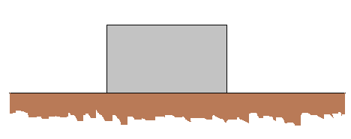
$$θ=45°$$
$${\vec{F}}_{2}$$
$${\vec{F}}_{1}$$
The angle θ is slowly decreased. If constant velocity is to be maintained then must ${\vec{F}}_{2}$ increase, decrease or remain the same? Explain (3)
Increase. By NW I $F_{net,x}=0⇒F_{1}\cos{θ}-F_{2}=0⇒F_{2}=F_{1}\cos{θ}$ as $θ$ decreases then $\cos{θ}$ increases hence so must $F_{2}$

- A man is pushing a heavy block up an incline at constant velocity. He decided to take a break and holds the block stationary on the incline. If the incline is frictionless, how does the force he applies to the block compare (in terms of its magnitude and direction) in the constant velocity case and in the stationary case. Explain (3)
In both cases it will be exactly equal. This is because in both cases the net force acting on the object is zero (Newton’s first law). Hence for the forces parallel to the slope then
$$F_{app}-F_{g,∥}=0$$
For both cases, hence $F_{app}$ is the same for both cases

- When a ball is thrown upwards and you can ignore air resistance, the velocity at its maximum height is zero. Does this mean that the forces acting on the ball at this point are in equilibrium? Explain (3)
No. A projectile will only experience one force (i.e. the force of gravity) throughout its entire motion and hence since this force is always nonzero then the net force acting on the object is never zero.

- In general the normal force acting on an object is not equal to its weight. Give three different examples of where the normal force is not equal to the weight of the object (3)
Any three suitable examples

Question 2 [9]
A book is held stationary against an inclined by applying a force perpendicularly to the surface as shown in the diagram below.

$${\vec{F}}_{app}$$
$$θ$$
If the force applied is increased, will the magnitude of the following quantities increase, decrease or remain the same? Explain your answers
- $f_{s}$ (3)
Stays the same. ${\vec{f}}_{s}$ prohibits motion down the slope which is caused by gravity and hence by NWI $f_{s}-F_{g,//}=0$ and since changing $F_{app}$ does not change $F_{g,//}$ then $f_{s}$ cannot change either

- $F_{N}$ (3)
Increases. By NW I perpendicular to the slope $F_{N}-F_{app}-F_{g,⊥}=0$ since mass has not changed then neither can $F_{g,⊥}$ thus the increase in $F_{app}$ must mean an increase in $F_{N}$

- $f_{s,max}$ (3)
Increases. Since $f_{s,max}=μ_{s}F_{N}$ and $F_{N}$ increases (as explained in (b)) then so must $f_{s,max}$

Question 3 [13]
A force $\vec{P}=-15N\hat{i}$ acts on a block weighing 45N. The block is initially at rest on an inclined plane at 15° to the horizontal. Up the slope is the positive x-axis. The coefficients of friction between the block and plane are $μ_{s}=0.50$ and $μ_{k}=0.34$.
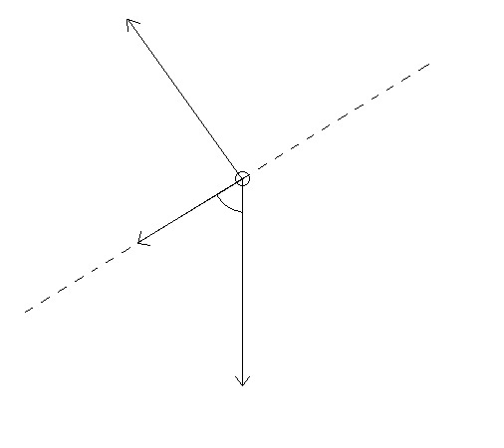
Draw a free-body diagram for the situation described above. (4)
$${\vec{F}}_{g}$$
$$\vec{P}$$
$${\vec{F}}_{N}$$
75°
$$\vec{f}$$

Find the magnitude of the normal force acting on the block. (3)
By NW I: $F_{net,y}=0⇒F_{N}-F_{g,⊥}=0⇒F_{N}-45\cos{15°}=0$
$$⇒F_{N}=45\cos{15°}=43.5N$$

Find the friction force acting on the object in unit vector notation. (6)
Assume object is stationary:
By NW I: $F_{net,x}=0⇒f-F_{g,//}-P=0⇒f_{s}-45\sin{15°-15}=0$
$$⇒f_{s}=45\sin{15°+15}=27N$$
But $f_{s,max}=μ_{s}F_{N}=0.5\left(45\cos{15°}\right)=21.7N$
Thus $f_{s}>f_{s,max}$ which is impossible and our assumption is false i.e. object is down ramp
Hence $\vec{f}=f_{k}\hat{i}=μ_{k}F_{N}\hat{i}=0.34\left(45\cos{15°}\right)\hat{i}=14.8N\hat{i}$

Question 4 [12]
- Two forces which do zero work in most cases are static friction and the normal force. These forces however do zero work for two very different reasons. Explain when and why each of these forces do zero work. (3)
$W=Fd\cos{θ}$ where $θ$ is angle between $F$ and $d$. $F_{N}$ does no work since in most cases it is perpendicular to motion. In all cases$f_{s}$ does no work since it only applied to stationary bodies and in that case $d=0$

- If an object moves from a point A to a point B at constant velocity then the net work done on this object is zero. If the net work done on the object between two points A and B is zero then does this mean that the velocity the box travels at between these two points is a constant value? (3)
No. The object just needs to have the same initial and final velocities in order for the net work to be zero as is stipulated by the Work-Kinetic energy theorem. The value of velocity between the two points may vary so long as this criteria is met.

- Spring A is stiffer than spring B ($k_{A}>k_{B}$). Which spring will do more work if the springs are compressed by:
- the same distance. Explain (3)
A will do more work. $W=\frac{1}{2}kx_{i}^{2}-\frac{1}{2}kx_{f}^{2}$ thus if they are compressed the same distance ($x_{i}^{2}-x_{f}^{2}$is the same) then the spring with the higher spring constant does more work
- the same magnitude force. Explain (3)
B will do more work. Since F=-kx then by keeping F the same in both cases this means that the distance compressed for A will be proportionally smaller than the distance compressed for B e.g. if A is twice as stiff as B then B will be compressed twice as much. However work relies on the square of the compressed distance so then B will do more work since it has been compressed the larger distance i.e. the work done by spring A in this case $W_{A}=-\frac{1}{2}k_{A}x_{A}^{2}=-\frac{1}{2}{2k}_{B}{\left(\frac{x_{B}}{2}\right)}^{2}=-\frac{1}{4}k_{B}x_{B}^{2}=\frac{W_{B}}{2}$ since $x_{A}=\frac{F}{k_{A}}=\frac{F}{2k_{B}}=\frac{x_{B}}{2}$

Question 5 [10]
Genetic manipulation and modification have enabled a group of daring scientists to recreate dinosaurs and wish to create a theme park/zoo where the exhibits are living dinosaurs. You have been commissioned by the park as an independent “expert” to sign off on the safety of the park. Not unexpectedly the dinosaurs escaped and now all the scientists are dead. You managed to escape the slaughter by bravely hiding away are left to fend for yourself. Currently you are on top of a storage shed looking at the exit to the park. Unfortunately a velociraptor is between you and freedom. After doing a quick inspection of the shed you manage to assemble a canon that hurls rocks based on a spring system and strap it to the roof as shown below:
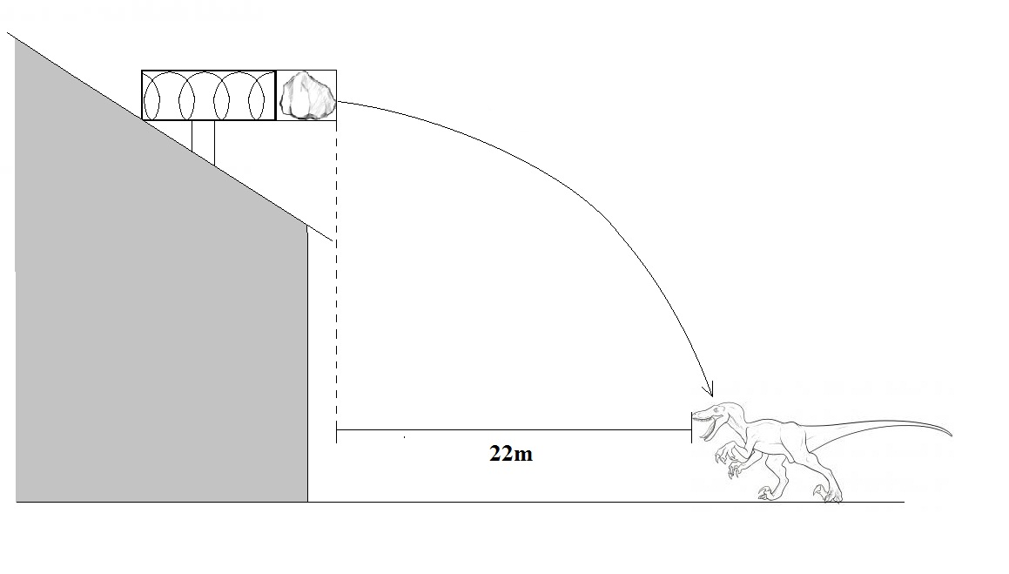
On the first shot you compress the spring 20 cm but the rock falls 30cm short of the velociraptors head. Taking a second rock of equal mass, how far should you compress the spring in order to hit the beast on its head? Show ALL your working
By conservation of mechanical energy in the cannon:
$\frac{1}{2}kx^{2}=\frac{1}{2}mv^{2}$ (1)
Since after the rock leaves the canon it is a projectile with zero vertical velocity
$h=\frac{1}{2}gt^{2}$ and $v=\frac{d}{t}$ where d is horizontal distance travelled
Hence $v=\frac{d}{\sqrt{\frac{2h}{g}}}⇒v^{2}=\frac{d^{2}g}{2h}$ (2)
Combining (1) and (2) one gets
$$kx^{2}=\frac{d^{2}gm}{2h}$$
$$\frac{x^{2}}{d^{2}}=\frac{gm}{2kh}$$
Since $\frac{gm}{2kh}$ is a constant value then it is the same for both shots and
$${\left(\frac{x^{2}}{d^{2}}\right)}_{1st shot}=\frac{gm}{2kh}={\left(\frac{x^{2}}{d^{2}}\right)}_{2nd shot}$$
$$\frac{{(0.20)}^{2}}{{21.7}^{2}}=\frac{x^{2}}{{22}^{2}}⇒x=20.28cm$$
Question 6 [11]
The diagram below shows a composite slab constructed from equal volumes of iron (density = $7.85 g/{cm}^{3}$) and aluminium (density = $2.70 g/{cm}^{3}$)
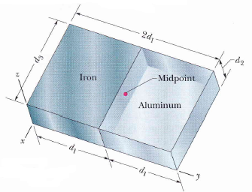
The dimensions of the slab are $d_{1}=11.0 cm, d_{2}=2.80 cm$ and $d_{3}=13.0 cm$
Find the centre of mass of the slab
By symmetry $x_{com} = –d_{1}/2 = –(13 cm)/2 = – 6.5 cm$. The negative value is due to our choice of the origin.
We find $y_{com}$ as
$$y_{com}=\frac{1}{M}\sum{m_{i}y_{i}}=\frac{1}{M}\sum{ρ_{i}V_{i}y_{i}}=\frac{ρ_{iron}V_{iron}y_{iron}+ρ_{aluminium}V_{aluminium}y_{aluminium}}{ρ_{iron}V_{iron}+ρ_{aluminium}V_{aluminium}}$$
$$=\frac{ρ_{iron}y_{iron}+ρ_{aluminium}y_{aluminium}}{ρ_{iron}+ρ_{aluminium}}=\frac{\frac{11}{2}\left(7.85\right)+3\left(\frac{11}{2}\right)(2.7)}{7.85+2.7}=8.3 cm$$
Again by symmetry, we have $z_{com}=(2.8 cm)/2 = 1.4 cm$.

Question 7 [8]
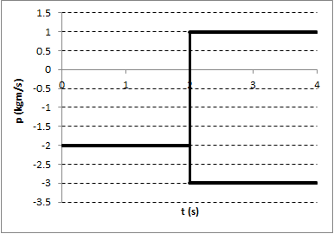
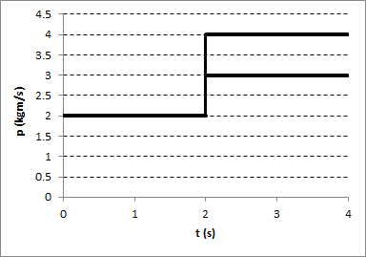
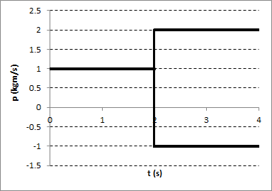
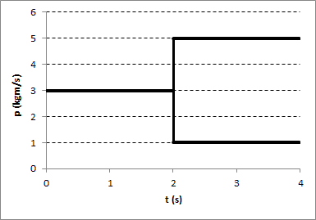
- A block and frictionless floor form a closed isolated system. At some stage during the blocks motion it explodes into two pieces. Which of the following graphs representing momentum of the block as a function are physically impossible? Explain your answer (4)
(d)
(c)
(b)
(a)
A and C. In a closed isolated system the total linear momentum must be conserved at all stages. In these two cases $P_{i}≠p_{1}+p_{2}$

- Below are four graphs of position versus time for two bodies and their centre of mass in different situations. The two bodies form a closed, isolated system and undergo a completely inelastic, one dimensional collision on an x axis. Which graphs correspond to a physically impossible situation? Explain (4)
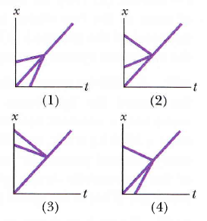
2 and 3. In a closed and isolated system the centre of mass must be between the two object and must undergo no changes in its velocity. This means that middle graph must be the centre of mass and in order to be physically possible this line cannot have a change in gradient when the two objects collide (which happens in 2 and 3)

Formula Sheet
$${\vec{F}}_{net}=m\vec{a}$$
$f_{s,max}=μ_{s}F_{N}$ $f_{k}=μ_{k}F_{N}$
$W=\int{F\left(x\right)dx}$ $W=\vec{F}∙\vec{d}=Fd\cos{φ}$
$$W_{net}=∆E_{k}$$
$$F=-\frac{dE_{p}}{dx}$$
$$W=∆E_{mech}+{∆E}_{th}+∆E_{int}$$
$${\vec{r}}_{com}=\frac{1}{M}\sum{m_{i}{\vec{r}}_{i}^{2}}$$
${\vec{F}}_{net}=M{\vec{a}}_{com}$ ${\vec{F}}_{net}=\frac{d\vec{P}}{dt}$
$$\vec{J}=\int_{t_{i}}^{t_{f}}{\vec{F}\left(t\right)dt}$$

